Isabelle Bérubé

A heart that beats for its city

When she made the big decision to leave the Plateau Mont-Royal to find a place better suited to family life, Isabelle Bérubé and her husband quickly turned their eyes to Saint-Bruno. The green canopy, the proximity of Mount Saint-Bruno Park, the access to Montreal by public transportation and the exceptional quality of life they had heard so much about were the determining factors. The choice was obvious and three children (and a dog!) later, they have never regretted it.

A city councillor since 2013 (District 3, then District 5), her involvement in the Montarvillian community is the natural outcome of her personality. When I was young, I had an inclusive attitude towards those around me, and I always took the side of the most vulnerable," she says. In short, I always wanted to do good for others. When I was first approached to enter municipal politics, I accepted because I was convinced that working for the good of my community would be the opportunity that would not come around twice."

In addition to her work as director of a major non-profit organization dedicated to protecting nature, her role as a St. Bruno councillor has led her to sit on numerous citizen committees (environment, mobility and traffic, urban planning).

She has also served as co-chair of the Commission de l'aménagement et de l'environnement de l'agglomération de Longueuil since 2013 and as a director on the boards of the Réseau de transport en commun de Longueuil and the Régie intermunicipale des eaux usées de Saint-Bruno et Saint-Basile-le-Grand.

Her top priorities are the protection of Saint-Bruno's green spaces and the vitality of the downtown area. "Montarvillois are not always aware of the exceptional character of our downtown," she says. "Unlike most suburban cities, it is surrounded by residential neighbourhoods rather than being located on a major urban boulevard. It needs to be protected and even further invigorated. A beating heart makes our hearts beat too. It's a valuable meeting place for community life." Aware that some businesses have suffered greatly from the pandemic, she wishes to put various initiatives in place so that they prosper and remain the first choice of the city's citizens.

An accomplished manager, Isabelle has held a variety of management positions throughout her career, including editor-in-chief in the agricultural world and publisher of a publication dedicated to agricultural news and policy. She has a leadership style that her employees and colleagues have always described as inclusive and caring: "I listen a lot before making a decision, always for the greater good. I am empathetic but also extremely lucid and aware of the multiplicity of issues. I am therefore ready to put my knowledge and skills at the service of the citizens for the next four years".

An inspiring mayor for an inspiring city!

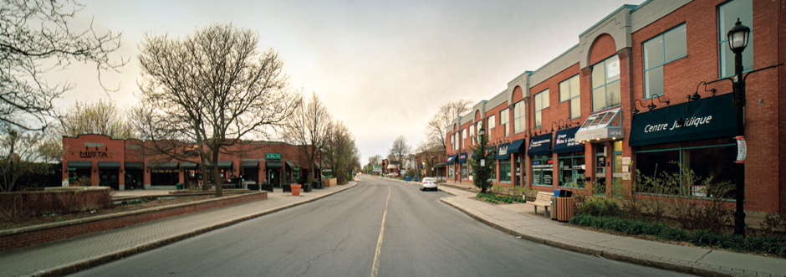

OUR DOWNTOWN: A HEART THAT BEATS FOR YOU

Together, for an attractive and collaborative village center!

Saint-Bruno is one of the few cities in the Montreal suburbs with a downtown that offers such a wide variety of services and businesses. However, now, more than ever, our businesses need our support. As they recover from an unprecedented crisis, they face labour shortages and need to adapt to more online shopping. Therefore, one of Ensemble Saint-Bruno's priorities is to revitalize the downtown area.

There are many opportunities to help our businesses. For example, more Montarvillians are working from home, which could increase local demand. Some will seek out collaborative workspaces to socialize or share interests. Others will have more time to enjoy lively public spaces or want more patios. In addition, many consumers have changed their habits, and we are experiencing an explosion of online sales, take-out orders, and food deliveries.

We need to rethink commercial street infrastructure to encourage local businesses and enhance the experience for families and seniors. We need to ensure the safety of people biking and walking downtown, allow for more patios and kiosks, plant trees, and encourage shopping on foot while maintaining maximum parking.

The health of a city center depends on several factors, including the friendliness of the area and the animation that attracts and retains visitors. Arts and culture deserve a permanent and dedicated space downtown.

In short, our downtown will go through a series of transformations, and it is in our interest to ensure that businesses come out ahead.

Ensemble Saint-Bruno is ready to take on this challenge.

Thus, we are committed to working with merchants and the population to:

- Modernize the infrastructure and the layout of our commercial streets

- Set up a home delivery service in partnership with the municipality

- Transform the temporary public market area into a permanent multi-functional gathering place, a true crossroads where citizens can meet, which could include a performance stage, an art space, a mobile market, and children's play areas. Public consultation with residents and local businesses will allow us to make this dream a reality to meet the needs of our community.

We will support the creation of a non-profit to launch a "repair cafe" type workshop.

Repair cafes have proven to be successful elsewhere, such as in Montreal (see: www.monatelier.ca). They encourage the transfer of knowledge, the sharing of tools, the repair of all kinds of appliances and the purchase of materials while offering an intergenerational meeting place. And why not add a bulk supply of hardware parts like we used to find at Mandeville?

We will adopt a building architecture regulation to ensure that future buildings in the downtown area are more harmonious and respectful of its history.

Ensemble Saint-Bruno believes that soft densification is possible while respecting the character of our village.

TOGETHER FOR A BEAUTIFUL AND PEACEFUL CITY

Together, let's make Saint-Bruno a city where it's good to grow up, flourish and age.

The population of Saint-Bruno is one of the oldest in the agglomeration.
Every year, households leave Saint-Bruno to find a home that matches their income. Ensemble Saint-Bruno wishes to improve the quality of life of seniors through concrete measures allowing them greater financial and housing autonomy while promoting all forms of solidarity between generations.

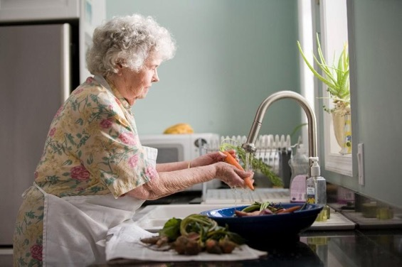

Our commitments:

To work with local organizations to encourage home support measures and develop an affordable housing offer for seniors.

To offer complimentary financial support to people who receive the federal government's guaranteed income supplement to help them have a more decent income.

Establish a municipal seniors' council.

Better meet the needs of caregivers (respite, work/caregiver balance, emergency card)

Provide more crosswalks on our commercial streets and improve safety.

Encourage intergenerational activities and spaces (see our "repair cafe" proposal on page X).

Improve snow and ice removal methods on streets, sidewalks, and bike paths to promote active transportation and safety.

The lack of childcare is a major irritant for many parents.

We will quickly identify opportunities to improve the supply of subsidized daycare for young children (see our commitment in this regard on https://www.ensemblesaint-bruno.com/ under Communiqués)
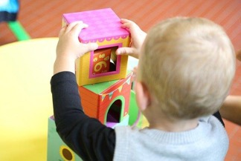

Access to affordable property is difficult for first-time buyers and young families.

We will adopt regulations to ensure the construction of affordable housing for families (see: https://stbruno.ca/ville/politiques-et-plans-daction/politique-habitation/) and develop a financial support program for first-time buyers.

Giving youth the place they deserve

In 2018, we adopted our very first Youth Policy, the result of a broad consultation with the youth of Saint-Bruno. As a result, we created activities such as The Youth Festival, the Night of Humour, the Parc Éphémère, and the movie theatre for 16 to 25-year-olds. As of January 2022, we will continue the work of the Youth Tribune to offer even more activities dedicated to our youth.

PEACEFUL NEIGHBOURHOODS

Speed on the streets is a worry for many families and residents.

We will facilitate the implementation of street speeding measures.

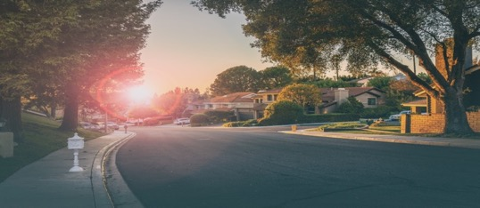

Airplane noise is affecting the peace of many neighbourhoods:

Together with citizens, we will initiate sustained representations with the appropriate authorities to reduce the nuisance caused by aircraft noise.

MORE BEAUTIFUL NEIGHBORHOODS

We love the beauty of our built heritage, and we want to protect it. Because Montarvillian's value their living environment, home remodelling is a sensitive issue in many neighbourhoods.

We will provide specific neighbourhoods with an architectural policy that respects the existing built heritage.

We will maintain and increase the budget allocated to street repairs to continue upgrading the infrastructure.

TOGETHER, LET'S MAKE SAINT-BRUNO A MODEL AND INSPIRATION IN RESPONDING TO THE CLIMATE EMERGENCY

At a time when many populations are feeling the full brunt of the climate crisis, Saint-Bruno-de-Montarville will take ambitious measures to reduce its greenhouse gas (GHG) emissions and adapt to climate disruption.

Reduce and adapt:
Cities and households can act on several fronts to reduce their GHG emissions and ensure better adaptation to extreme climate events: transportation, land use planning, energy consumption, waste management, responsible development, greening, responsible investment, reducing food waste, protecting woodlands, managing rainwater, etc.

Our commitments:
Our administration will adopt a proper climate plan aiming for carbon neutrality by 2035. It will contain indicators and targets for each municipal department and will encourage the participation of Montarvillian households. Everyone's efforts will be put to work.

We will offer financial assistance programs to encourage the energy transition of households who want to switch from oil to electricity for heating their homes or those who wish to replace their gas lawnmowers with electric ones. In addition, we will work with households who are renovating their homes to achieve energy savings.

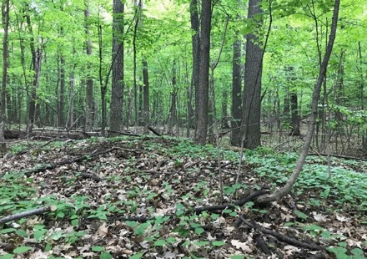

We will increase the number of trees by continuing to plant trees wherever possible.

Current tree coverage in Saint-Bruno: 30%

Targets: 40% by 2030 and 45% by 2040

Trees and nature are our best allies in the fight against climate change. They improve our quality of life and resilience to extreme weather events (heatwaves, intense rainfall, etc.)

We will continue to protect woodlands. The possibility of creating a Social Utility Trust will be submitted for debate.

We will continue to improve the public transit and evaluate the costs and opportunities for implementing of an electric shuttle linking the residential neighbourhoods to the village core.

We will accelerate the deployment of the municipality's Active Mobility Plan, which will improve the networks and the connection of existing routes. In particular, we will ensure the completion of the trail project along Montée Sabourin to secure the connection with the Promenades*. All connections to the village core will be prioritized.

We will conduct a pilot project in a residential neighbourhood to offer an electric car as a part of a sharing economy (available on subscriptions like Communauto). This initiative will reduce the pressure on households that have to buy a second or third car for occasional use**

In Saint-Bruno, 3.76% of all cars run on hydroelectricity.

Target: The provincial target is 14% of the vehicle fleet by 2026, or 300,000 vehicles for all of Quebec

We will improve infrastructure to ensure better stormwater management, for example, of harmful water runoff to the lake and sewer flow.

* This project is already planned and scheduled. We will ensure its realization.

** To find out the cost of this measure, write to us at info@ensemblesaint-bruno.com

A CITY THAT LISTENS

Together, let's make Saint-Bruno an innovative model of transparency and citizen participation.

We advocate more participatory democracy, and we want to increase the number of places for citizen expression and adopt more transparent processes.

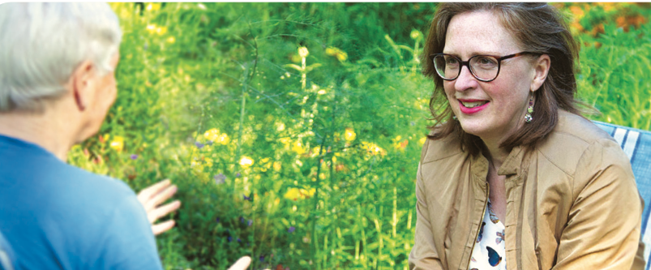

We are committed to:

Making all municipal studies public.

Communicating about municipal decisions made behind closed doors.
To view our commitment to this issue, go to https://www.ensemblesaint-bruno.com/ and “Communiqués.”

Continuing to implement the new public participation policy.
This includes creating a citizen's panel, deploying several mechanisms to involve citizens in projects and decision-making, and requiring the Council to be accountable to the public. In addition, we will deploy the right of citizens' initiatives in public consultation.

Initiating the creation of an innovation laboratory.
Citizens will be invited to submit a project that could be tested by a control group and then deployed if the idea proves successful.

Establishing citizen meetings in the districts.
The elected officials of Ensemble Saint-Bruno will be available for meetings with their district's residents at a pre-established frequency to ensure the follow-up and the assumption of responsibility for the files.

Renewing the mandates of the citizen advisory committees to ensure their contribution to municipal initiatives.

TOGETHER FOR RIGOROUS MUNICIPAL MANAGEMENT

Our economic situation is enviable, but we must remain vigilant. Therefore, we must tighten our spending to prioritize what is essential: the protection of our woodlands, the recovery from the pandemic, the construction of the sports complex, the health and safety of the population, support for local organizations, the repair of streets in poor condition and the climate emergency.

Taxation
We will align the tax rate with the inflation rateß and allow payments to be spread over 11 months without interest.

Spending and debt controls
We will allocate surpluses equally to debt repayment, the Woodlands Protection Trust, and the Climate Action Plan.

We will reduce our three-year capital plan (TCP) commitments, which have increased by 255% over the past two years.

Here is the city's total investment and borrowing in the ITP (2017 to 2021):

2017 = 41 710 000 $
2018 = 52 080 000 $
2019 = 124 235 000 $
2020 = 115 166 000 $
2021 = 132 998 000 $
Agglomeration of Longueuil Services
We will continue our representations to make the most of the $30M (i.e., 43% of our operating budget) that we transfer to the Agglomeration of Longueuil for services under their jurisdiction (police and firefighters, drinking water supply, public transit services, evaluation, and land use planning).

To learn more about our commitments and our vision for the future of Saint-Bruno, visit our website: https://www.ensemblesaint-bruno.com/

TOGETHER FOR A CITY OF SPORTS AND NATURE

Saint-Bruno is an extraordinary place to live for nature lovers. In addition to our many parks and woodlands, we are privileged to host the Parc National du Mont-Saint-Bruno and the Tailhandier Woodland Nature Reserve, two magnificent sites rich in biodiversity and mature forests. These spaces provide physical and mental health benefits to our community and act as cooling islands and carbon sinks.

Lockdowns have had a significant impact on park use, causing inconvenience to adjacent neighbourhoods. We need to protect Montarvillians' access to secondary park entrances while minimizing neighbourhood disturbance. These interventions require a thorough analysis of data and a re-evaluation of current practices.

We will evaluate the appropriateness of providing each Montarvillian household with a parking sticker to park on the streets surrounding these green spaces free of charge. Mitigation measures, such as one-side parking bans, will be put in place to limit the impact on residents' quality of life in these areas. To view our commitment to this issue: https://www.ensemblesaint-bruno.com/ under “Communiqués.”

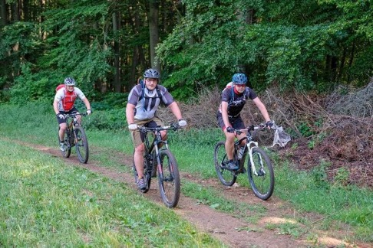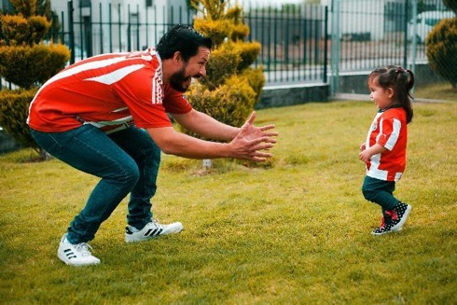

We will invest in green spaces and parks to beautify them and improve facilities (play modules, water games, sliding hills, neighbourhood skating rinks, etc.). Lac du Village and Parc de la Rabastalière will be the first to benefit from these investments.
Lac du Village: Algae and plants are choking the lake. The protection of this jewel of Montarvillois requires concrete actions based on science. Therefore, we will continue and enhance the implementation of the existing action plan*:

Reduce aquatic plant growth. This could include the installation of floating islands populated with native plants, as is done at the Botanical Garden.

Redesign the lakefront to incorporate native species.

Educate the public about the premature ageing of the lake.

Evaluate the interest in organizing soft water activities on the lake.

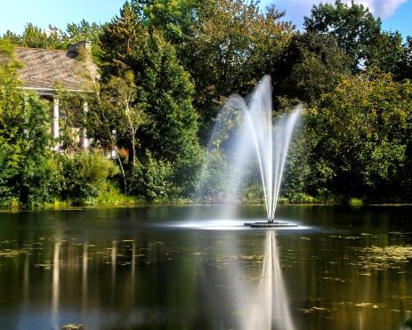

To improve the sports and recreation offer and meet the needs of community organizations, it is urgent that we build a new sports complex.

The climate emergency obliges us to consolidate the infrastructures close to the living environment of the greatest number of people to ensure accessibility**. To support the local economy, these infrastructures must also be close to restaurants, cafés, and stores. We must avoid repeating the mistake of building services far from people and businesses as was done with the commuter train station and the Marcel-Dulude Centre.

Therefore, we will focus on the site of the École Secondaire du Mont-Bruno to complete its construction quickly

To ensure maximum transparency throughout the process, we will actively involve citizens in the realization of the project while keeping them informed on a regular basis. Like all major projects, it will be subject to a referendum process as provided for in the Act.

The Saint-Bruno sports complex will be an inspiring project that will meet the most innovative requirements in terms of energy efficiency and architecture (water recovery, green roof, etc.).

Given the exceptional growth of cycling and to allow Montarvillians to practice this sport legally and in harmony with nature:

We will set up an NPO whose role will be to create a structured network of circuits and trails around Saint-Bruno that respect our natural spaces.

To see all the details of our commitment in this regard:
https://www.ensemblesaint-bruno.com/ under “Communiqués”.

* https://stbruno.ca/ville/politiques-et-plans-daction/plan-d-action-lacs/
** The notion of accessibility is essential to obtain subsidies for the realization of the complex

